MERN FULL STACK PROJECT REPORT

TITLE
SHOP SPHERE – ONLINE CLASSIFIED ADVERTISEMENT AND SHOPPING PLATFORM

TEAM NAME : TECH TITANS
TEAM NUMBER : 8

Submitted By
Name of Student | Register Number
Marapareddy Harshitha | 99230040661
Veeramreddy Peta Gnana Prasuna | 99230040450
Karra Prem sagar | 99230040332
Pacha Venkata Siva Naga Gopi | 99230040700
Lingala Seshanth Reddy | 99230040126
Nushi Purnachandhra Reddy | 99230040698

GUIDED BY
AJUSHA

ABSTRACT
SHOP SPHERE is a proposed web-based online classified advertisement and shopping platform designed to connect buyers and sellers through a single digital application. The project rebuilds the core idea of the existing Java-based ClassifiedShop application using the MERN stack, which consists of MongoDB, Express.js, React.js, and Node.js. The main objective is to provide a convenient, secure, responsive, and user-friendly environment for browsing products, publishing advertisements, managing listings, and placing orders.
The application is designed around three major roles: User, Seller, and Admin. Users can register, log in, browse available products, search by product name, filter by category, view product details, add items to a cart, place orders, review order history, and manage their profiles. Sellers can create and manage their own product listings, upload product images, update availability and product information, and view and process orders associated with their products. Administrators can monitor platform statistics, manage users and sellers, maintain product categories, oversee all product listings and orders, and block or unblock accounts when required.
The frontend is planned using React.js with Vite, React Router DOM, Axios, and React Icons. The backend is designed using Node.js and Express.js to provide RESTful APIs. MongoDB stores application data, while Mongoose defines schemas and manages database operations. JWT-based authentication and bcrypt password hashing are included in the security design. Multer is used for product image upload handling. Role-based authorization ensures that users, sellers, and administrators can access only the functions permitted for their roles.
This report describes the proposed system, requirements, architecture, database design, modules, implementation plan, and testing approach. Since the project is being prepared for development, test cases and result descriptions are verification plans. Actual execution results and application screenshots should be added after the corresponding modules have been implemented and tested.

TABLE OF CONTENTS
TITLE | PAGE NO.
ABSTRACT | ii
LIST OF TABLES / FIGURES | iv
CHAPTER 1 – INTRODUCTION | 1
1.1 Introduction | 1
1.2 Problem Statement | 2
1.3 Objectives | 2
1.4 Scope | 2
CHAPTER 2 – SYSTEM ANALYSIS | 3
2.1 Introduction | 3
2.2 Existing System | 3
2.3 Limitations | 4
2.4 Proposed System | 4
2.5 Features | 5
2.6 Functional Requirements | 5
2.7 Non-Functional Requirements | 5
2.8 Hardware Requirements | 6
2.9 Software Requirements | 6
2.10 Feasibility Study | 6
2.11 Summary | 6
CHAPTER 3 – SYSTEM DESIGN | 7
3.1 Introduction | 7
3.2 Architecture | 8
3.3 Data Flow | 8
3.4 Database Design | 8
3.5 Module Design | 9
3.6 Security Design | 9
3.7 Summary | 9
CHAPTER 4 – SYSTEM IMPLEMENTATION | 10
4.1 Introduction | 10
4.2 Frontend | 10
4.3 Backend | 10
4.4 Database | 11
4.5 Authentication | 11
4.6 Product and Cart | 11
4.7 Orders and Admin | 11
4.8 Summary | 11
CHAPTER 5 – SYSTEM TESTING | 12
5.1 Introduction | 12
5.2 Testing Types | 12
5.3 Test Cases | 12
5.4 Testing Result | 13
5.5 Summary | 13
CHAPTER 6 – RESULTS AND SCREENSHOTS | 14
6.1 Introduction | 14
6.2 User Module | 15
6.3 Seller Module | 16
6.4 Admin Module | 16
6.5 Overall Result | 17
CHAPTER 7 – CONCLUSION AND FUTURE ENHANCEMENT | 18
7.1 Conclusion | 18
7.2 Future Enhancements | 18
7.3 Final Summary | 18

LIST OF TABLES
TABLE NO. | DETAILS
Table 1 | Hardware Requirements
Table 2 | Software Requirements
Table 3 | Database Collections
Table 4 | Functional Test Cases

LIST OF FIGURES
FIGURE NO. | DETAILS
Figure 1 | SHOP SPHERE System Architecture
Figure 2 | User Registration and Login Flow
Figure 3 | Product Listing and Order Flow
Figure 4 | Interested Buyers
Figure 5 | Seller Dashboard and product management
Figure 6 | Seller order Page

CHAPTER 1
INTRODUCTION

1.1 Introduction
SHOP SPHERE is an online classified advertisement and shopping platform that provides a common digital space for buyers and sellers. In a traditional classified system, customers may need to search across different sources to find products, while sellers may depend on informal communication or separate platforms to advertise their products. SHOP SPHERE aims to organize these activities through a single web application.
The project is inspired by the existing Java-based ClassifiedShop application. The proposed version is redesigned using the MERN stack to provide a modern interface, modular architecture, responsive pages, and REST API-based communication. The system includes separate facilities for users, sellers, and administrators. Users can discover products and place orders, sellers can publish and maintain their own listings, and administrators can supervise platform activities.
The frontend is developed using React.js and Vite. React Router DOM supports page navigation, while Axios communicates with backend APIs. Node.js and Express.js manage server-side operations. MongoDB stores users, sellers, products, categories, carts, and orders. Mongoose is used to define data models and relationships. JWT authentication, bcrypt password hashing, and role-based middleware protect application resources.

1.2 Problem Statement
Many small classified and shopping applications do not provide a unified and well-organized process for buyers, sellers, and administrators. Buyers may face difficulty finding relevant products, comparing listings, and tracking orders. Sellers may not have a dedicated dashboard to manage product details, images, availability, and customer orders. Platform administrators may find it difficult to monitor accounts, categories, products, and order activity from one place.
- Product information may be scattered across multiple sources, making discovery difficult.
- Buyers need convenient search and category filtering to locate relevant products.
- Sellers require a simple way to create, edit, and remove their own product advertisements.
- Manual listing management can cause outdated product details and availability information.
- Users need a centralized cart and order history to manage purchases.
- Administrators require centralized controls for users, sellers, categories, products, and orders.
- Unauthorized access must be prevented so each role can perform only permitted operations.
Therefore, a centralized MERN-based classified shopping platform is proposed to simplify product discovery, listing management, order processing, and platform administration.

1.3 Objectives of the Project
- To rebuild the ClassifiedShop concept using MongoDB, Express.js, React.js, and Node.js.
- To develop secure registration, login, logout, and profile management.
- To provide product browsing, search, category filtering, and product detail pages.
- To allow users to add products to a cart, update quantities, remove items, and place orders.
- To provide sellers with facilities to create, update, delete, and view their own listings.
- To allow sellers to view orders related to their products and update order status.
- To develop an admin dashboard for platform statistics and management operations.
- To implement JWT authentication, bcrypt password hashing, input validation, and role-based authorization.
- To create a responsive interface for desktop, tablet, and mobile devices.

1.4 Scope of the Project
The scope of SHOP SPHERE covers the core operations of an online classified advertisement and shopping platform. The application is designed for three roles.

User Module
- Register and log in securely.
- Browse, search, and filter products.
- View product descriptions, images, seller details, condition, and location.
- Manage cart items and quantities.
- Place orders and view order history.
- Update profile details and change password.

Seller Module
- Register and log in as a seller.
- Create product advertisements and upload images.
- Update or delete only the seller's own products.
- View listed products and availability.
- View customer orders containing the seller's products.
- Update order status and manage seller profile.

Admin Module
- View total users, sellers, products, and orders.
- Manage user and seller accounts.
- Block or unblock users and sellers.
- Create, update, and delete product categories.
- View and manage all products and orders.
- Monitor platform statistics.
The scope also includes backend REST APIs, MongoDB data storage, image upload handling, authentication, authorization, and responsive frontend pages. Live payment processing, delivery partner integration, chat, and mobile applications are possible future enhancements unless separately implemented.

CHAPTER 2
SYSTEM ANALYSIS
System analysis identifies the requirements, resources, limitations, and expected behaviour of the proposed SHOP SPHERE application.

2.1 Introduction
SHOP SPHERE connects buyers, sellers, and administrators through a centralized web platform. System analysis defines the features required by each role and the technical resources needed to implement them.

2.2 Analysis of the Existing System
The existing project is a Java-based ClassifiedShop application. The present task is to rebuild its core classified shopping functionality using the MERN stack. In a basic classified shopping workflow, buyers search for products and sellers publish advertisements. When product listings, account details, and order information are handled through separate or limited interfaces, users may experience difficulty managing the complete process.
- Buyers browse product advertisements to identify suitable items.
- Sellers provide product details and images for advertisements.
- Product information and seller details are maintained in application records.
- Users proceed through the purchase workflow supported by the application.
- Administrators supervise listings and user activity where management facilities are available.
The exact feature-by-feature behaviour of the original Java application should be confirmed by reviewing its source code. This report uses the core ClassifiedShop concept supplied in the project brief and does not assume undocumented features.

2.3 Limitations of the Existing System
- Technology migration: the Java-based application does not use the requested MERN architecture and React component workflow.
- User experience: a redesigned interface is required for responsive layouts and consistent navigation.
- Role management: the proposed application requires clearly separated user, seller, and admin dashboards.
- Listing ownership: seller operations must ensure that a seller cannot edit or delete another seller's products.
- Shopping workflow: the proposed scope includes an integrated cart, quantity management, order placement, and order history.
- Administration: a centralized dashboard is required for users, sellers, categories, products, orders, and statistics.

2.4 Proposed System
The proposed SHOP SPHERE system is a full-stack web application developed using the MERN stack. React.js provides the user interface, Express.js exposes REST APIs, Node.js executes backend logic, and MongoDB stores application data. Mongoose schemas define the main collections and their references.
Users can discover products and complete a cart-to-order workflow. Sellers can manage their own listings and process relevant orders. Administrators can manage the complete platform. JWT authentication is used to authenticate requests, while middleware checks the authenticated role before allowing access to protected endpoints. Passwords are hashed using bcrypt before storage.

2.5 Features of the Proposed System

1. User Management
- Registration, login, logout, and profile management.
- Password change and protected user pages.

2. Product Discovery
- Browse available products.
- Search by product name and filter by category.
- View product images, description, price, condition, location, and seller details.

3. Cart and Orders
- Add and remove cart items.
- Update item quantities.
- Place orders and view order history.

4. Seller Management
- Create, read, update, and delete own product listings.
- Upload product images and manage availability.
- View customer orders and update order status.

5. Admin Management
- View platform counts and statistics.
- Manage users, sellers, categories, products, and orders.
- Block or unblock accounts.

6. Authentication and Security
- JWT authentication and role-based authorization.
- bcrypt password hashing and request validation.
- Seller ownership checks and protected APIs.

2.6 Functional Requirements

2.6.1 User Functional Requirements
- The system must allow a new user to register using valid details.
- Registered users must be able to log in and log out.
- Users must be able to browse products, search by name, and filter by category.
- Users must be able to view complete product details.
- Users must be able to add products to the cart, change quantities, and remove items.
- Users must be able to place orders and view order history.
- Users must be able to update their profile and change password.

2.6.2 Seller Functional Requirements
- The system must provide seller registration and login.
- Sellers must be able to add products with name, description, price, category, image, condition, location, and availability.
- Sellers must be able to view, update, and delete only their own products.
- Sellers must be able to upload and preview product images.
- Sellers must be able to view orders associated with their products.
- Sellers must be able to update permitted order statuses and manage their profiles.

2.6.3 Admin Functional Requirements
- The administrator must be able to log in through a protected admin facility.
- The admin dashboard must display counts of users, sellers, products, and orders.
- The administrator must be able to manage user and seller accounts.
- The administrator must be able to block and unblock users and sellers.
- The administrator must be able to create, update, and delete categories.
- The administrator must be able to manage all products and view all orders.

2.7 Non-Functional Requirements
- Security: passwords must be hashed; protected APIs must verify JWT tokens and roles; ownership must be checked on seller operations.
- Usability: the interface should use clear navigation, readable typography, validation messages, and consistent controls.
- Performance: API requests and database queries should return required data efficiently.
- Reliability: the application should handle invalid requests and database errors without exposing sensitive server details.
- Scalability: modular frontend, backend, and database structures should support future growth.
- Maintainability: components, routes, controllers, models, and middleware should be separated by responsibility.
- Responsiveness: pages should adapt to desktop, tablet, and mobile screen sizes.
- Data integrity: order items should retain required product and price details for order history.

2.8 Hardware Requirements
Component | Minimum / Recommended Requirement
Processor | Intel Core i3 or equivalent
RAM | 4 GB minimum; 8 GB recommended
Storage | 5–10 GB free space
Display | Standard monitor or laptop display
Input Devices | Keyboard and mouse
Network | Internet connection

2.9 Software Requirements
Software / Technology | Purpose
React.js + Vite | Frontend user interface
HTML5, CSS3, JavaScript | Page structure, styling, application logic
React Router DOM | Client-side navigation
Axios | HTTP communication
React Icons | Interface icons
Node.js | Backend runtime
Express.js | REST API development
MongoDB | Database management
Mongoose | MongoDB object modelling
JWT | Authentication
bcrypt.js | Password hashing
Multer | Product image upload
VS Code / Postman | Development and API testing

2.10 Feasibility Study

2.10.1 Technical Feasibility
The project is technically feasible because the MERN stack provides the technologies required for frontend development, backend API creation, database operations, authentication, and file uploads. These technologies are widely used and documented.

2.10.2 Economic Feasibility
The project can be developed with low software cost because React, Node.js, Express.js, MongoDB development tools, and Visual Studio Code are available without purchasing expensive proprietary software. Hosting, domain, and cloud storage costs may apply during deployment.

2.10.3 Operational Feasibility
The application is operationally feasible because users, sellers, and administrators interact through role-specific pages. Basic web browsing knowledge is sufficient to use the system.

2.10.4 Schedule Feasibility
The project can be organized into project setup, backend and database development, frontend development, API integration, module testing, and deployment. Completing and testing one module at a time helps control development progress.

2.11 Summary
This chapter presented the existing approach, limitations, proposed SHOP SPHERE system, functional and non-functional requirements, hardware and software requirements, and feasibility study.

CHAPTER 3
SYSTEM DESIGN

3.1 Introduction
System design explains the architecture, data flow, database structure, modules, and security controls of SHOP SPHERE. The design separates frontend, backend, and database responsibilities.

3.2 System Architecture
SHOP SPHERE follows a three-layer MERN architecture. The frontend uses React.js and Vite; the backend uses Node.js and Express.js; MongoDB stores application data through Mongoose models. Multer handles image uploads, while JWT and role middleware protect restricted operations.
USER / SELLER / ADMIN
|
v
REACT.JS + VITE FRONTEND
Pages | Components | Context | Axios | React Router
| HTTP / JSON / JWT
v
NODE.JS + EXPRESS REST API
Routes -> Middleware -> Controllers -> Validation
| |
| +--> MULTER IMAGE UPLOADS
v
MONGOOSE MODELS
|
v
MONGODB DATABASE
Users | Sellers | Admins | Products | Categories | Carts | Orders
Figure 1: SHOP SPHERE System Architecture

3.3 Data Flow Design

Level 0 – Context Flow
The User sends registration, search, cart, profile, and order requests. The Seller sends listing and order-management requests. The Admin sends platform-management requests. The system validates each request, reads or updates MongoDB, and returns the appropriate response.

Level 1 – Main Data Flow
- A user, seller, or administrator submits registration or login details.
- The backend validates credentials and verifies the account record.
- The backend compares the password hash and issues a JWT after successful authentication.
- The frontend uses the authenticated session to request role-protected data.
- Users browse products, search, filter, and view product details.
- Users add products to the cart, update quantities, and submit an order.
- Sellers create or update their own listings and process relevant orders.
- Administrators manage accounts, categories, products, and orders.
- The backend stores changes in MongoDB and returns the result.

3.4 Database Design
MongoDB is the primary database and Mongoose defines schemas and references. The proposed collections are:
Collection | Important Fields / Purpose
Users | name, email, passwordHash, phone, address, isBlocked, createdAt
Sellers | name, email, passwordHash, phone, businessName, address, isBlocked, createdAt
Admins | name, email, passwordHash, role, createdAt
Products | name, description, price, categoryId, image, sellerId, condition, location, availabilityStatus, createdAt
Categories | name, description, isActive, createdAt
Carts | userId, items [productId, quantity], updatedAt
Orders | userId, items [productId, sellerId, productName, unitPrice, quantity], totalAmount, shippingAddress, status, createdAt

Relationships are maintained using MongoDB ObjectIds. A product references its seller and category. A cart references its user and selected products. An order references the purchasing user and stores order item details. Seller-specific queries must filter by the authenticated seller ID. Admin operations may access platform-wide records after admin authorization.

3.5 Module Design

1. User Module
- Registration, login, logout, and profile management.
- Product browsing, search, category filter, and product details.
- Cart management, order placement, and order history.

2. Seller Module
- Seller registration and login.
- Product creation, image upload, update, deletion, and listing view.
- Customer order view and order status management.

3. Admin Module
- Dashboard statistics.
- User and seller management, including block and unblock.
- Category, product, and order management.

4. Product Module
- Product validation and category association.
- Image handling, availability, condition, and location.
- Public product listing and product detail retrieval.

5. Cart and Order Module
- Cart item addition, removal, and quantity updates.
- Server-side order total calculation.
- Order history and seller-specific order access.

6. Authentication Module
- Password hashing and credential verification.
- JWT creation and verification.
- Role and ownership middleware.

3.6 Security Design
- Passwords are stored only as bcrypt hashes; plain-text passwords are never stored.
- JWT tokens are verified by authentication middleware before protected operations.
- Role-based middleware restricts admin, seller, and user endpoints.
- Seller update and delete operations verify product ownership on the server.
- Order access is restricted to the purchasing user, relevant seller, or authorized administrator.
- Request bodies, IDs, prices, quantities, and uploaded files are validated on the backend.
- Environment variables store database connection strings and JWT secrets.
- Error responses must not expose passwords, tokens, credentials, or internal stack traces.

3.7 Summary
This chapter described the proposed MERN architecture, data flow, MongoDB collections, application modules, and security design.

CHAPTER 4
SYSTEM IMPLEMENTATION

4.1 Introduction
System implementation converts the design into a working application. SHOP SPHERE is planned as separate frontend and backend projects. The backend exposes REST APIs and communicates with MongoDB, while the React frontend consumes those APIs.

4.2 Frontend Implementation
The frontend is developed using React.js with Vite. The application is divided into reusable components, pages, role-specific dashboards, context providers, and service modules.
- Common components include navigation bar, footer, product card, search bar, category selector, loading indicator, notification, and confirmation dialog.
- Public pages include homepage, product listing, product details, About Us, and Contact Us.
- Authentication pages include user registration, user login, seller registration, and seller login.
- User pages include dashboard, cart, order placement, order history, and profile.
- Seller pages include dashboard, add product, listed products, edit product, seller orders, and seller profile.
- Admin pages include dashboard, user management, seller management, category management, product management, and order management.
- Axios service functions communicate with backend APIs; React Router DOM handles navigation and protected pages.

4.3 Backend Implementation
The backend is developed using Node.js and Express.js. Routes define API endpoints, controllers implement business logic, models define database schemas, and middleware handles authentication, authorization, validation, uploads, and error responses.
Backend Folder | Responsibility
config/ | MongoDB connection and application configuration
controllers/ | Business logic for authentication, products, cart, orders, categories, and admin
middleware/ | JWT authentication, role checks, ownership checks, upload and error handling
models/ | Mongoose schemas for users, sellers, admins, products, categories, carts, and orders
routes/ | REST API route definitions
uploads/ | Local development location for uploaded product images
server.js | Express setup, middleware, routes, and server startup

4.4 Database Implementation
Mongoose models create and validate MongoDB documents. The database connection string is stored in an environment variable. Model references connect related records using ObjectIds. Indexes may be added for frequently searched fields such as product name, category, seller, and user email.

4.5 Authentication Implementation
- Registration endpoints validate required fields and check whether the email is already registered.
- The password is hashed using bcrypt.js before the account is saved.
- Login endpoints verify the submitted password against the stored hash.
- After successful login, the server creates a JWT containing the account identifier and role.
- Protected frontend routes improve navigation, while backend middleware provides actual security enforcement.
- Logout clears the client-side authentication state and removes the session token according to the selected token-storage strategy.
For production deployment, token storage should be selected carefully. HttpOnly, Secure, SameSite cookies are generally preferable to exposing long-lived tokens to JavaScript. If bearer tokens are used, appropriate storage and XSS protections should be applied.

4.6 Product and Cart Implementation
The product module supports creating, retrieving, updating, and deleting product records. A product contains its name, description, price, category, image, seller reference, condition, location, availability status, and date added. Public product APIs return products available for display. Seller update and delete operations verify ownership on the server.
The cart module stores selected product references and quantities for each user. The backend validates product availability and quantity values. The order total is calculated on the server using trusted product prices rather than accepting a total supplied by the browser.

4.7 Order and Admin Implementation
When a user places an order, the backend validates the cart, creates an order record, stores item details and the calculated total, and updates or clears the cart according to the defined workflow. Users can view their own order history. Sellers can view orders containing their products and update permitted statuses. Administrators can view all orders.
The admin dashboard retrieves summary counts for registered users, sellers, products, and orders. Admin APIs provide account blocking, category CRUD, product management, and order monitoring. Every admin endpoint must verify the administrator role on the backend.

4.8 Summary
This chapter explained the planned frontend, backend, database, authentication, product, cart, order, and admin implementation. Actual implementation status should be updated as each module is completed.

CHAPTER 5
SYSTEM TESTING

5.1 Introduction
System testing verifies whether SHOP SPHERE meets its functional and non-functional requirements. Testing should be performed after individual modules are implemented and again after frontend, backend, and database integration. The cases below are a proposed checklist; actual pass or fail status must be recorded during execution.

5.2 Types of Testing
- Unit Testing: checks individual functions, controllers, validation rules, and reusable frontend components.
- Integration Testing: checks communication between React, Express APIs, and MongoDB.
- Functional Testing: verifies registration, login, product management, cart, order, and admin operations.
- Validation Testing: checks required fields, email format, password rules, prices, quantities, and uploaded file types.
- Authorization Testing: checks that users cannot access seller/admin routes and sellers cannot modify another seller's records.
- UI Testing: checks layout, navigation, responsive behaviour, empty states, and error messages.
- Security Testing: checks password hashing, token validation, blocked account access, and unauthorized requests.

5.3 Test Cases
Test Case | Input / Action | Expected Result | Status
User registration | Submit valid user details | Account should be created and stored securely | To be tested
Duplicate registration | Use an existing email | Meaningful duplicate email error should appear | To be tested
User login | Submit valid credentials | User should receive authenticated access | To be tested
Invalid login | Submit incorrect password | Access should be denied with an error message | To be tested
Product search | Search using product name | Matching available products should be displayed | To be tested
Category filter | Select a category | Only matching products should be displayed | To be tested
Product details | Open a product card | Complete product information should be displayed | To be tested
Cart quantity | Change item quantity | Quantity and calculated total should update | To be tested
Order placement | Place order with valid cart | Order should be saved in MongoDB | To be tested
Seller product creation | Submit product details and image | Product should link to logged-in seller | To be tested
Seller ownership | Edit another seller's product | Backend should reject the operation | To be tested
Seller order view | Open seller orders | Only relevant order items should be visible | To be tested
Admin dashboard | Open as admin | Platform counts should be displayed | To be tested
Block user | Admin blocks a user | Blocked user should lose protected access | To be tested
Category CRUD | Create, update, delete category | Changes should reflect in database and UI | To be tested
Protected API | Call without valid token | Request should be rejected | To be tested

5.4 Testing Result
The application should be considered ready only after all critical test cases have been executed and results recorded. For each test, record the actual result, status (Pass/Fail), date, and any defect identified. Do not mark a test as passed until it has been run against the working application.

5.5 Summary
This chapter defined the testing methods and test cases required to verify SHOP SPHERE. Testing will confirm module behaviour, API integration, data storage, role restrictions, and responsive user experience.

CHAPTER 6
RESULTS AND DISCUSSION

6.1 Introduction
This chapter is reserved for presenting the actual output of SHOP SPHERE. The project brief describes the application to be developed rather than supplying a completed running application. Therefore, the screenshot areas below are placeholders and must be replaced with genuine screenshots after implementation.

6.2 User Module Results
After implementation, this section should show that users can register, log in, browse and search products, filter categories, view product details, manage the cart, place orders, and view order history.
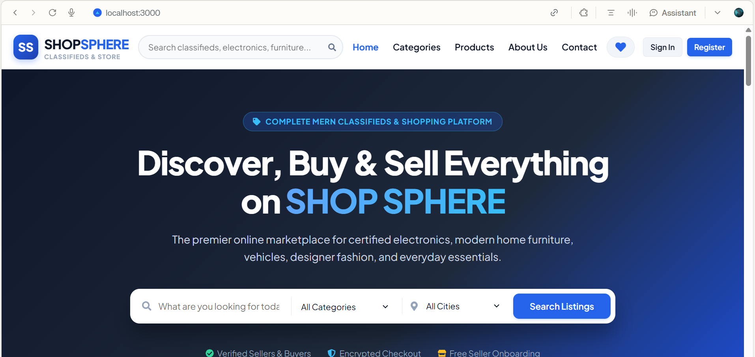
Figure 2: SHOP SPHERE Homepage
The homepage should display branding, navigation, search, popular categories, featured products, recently added products, and footer links.
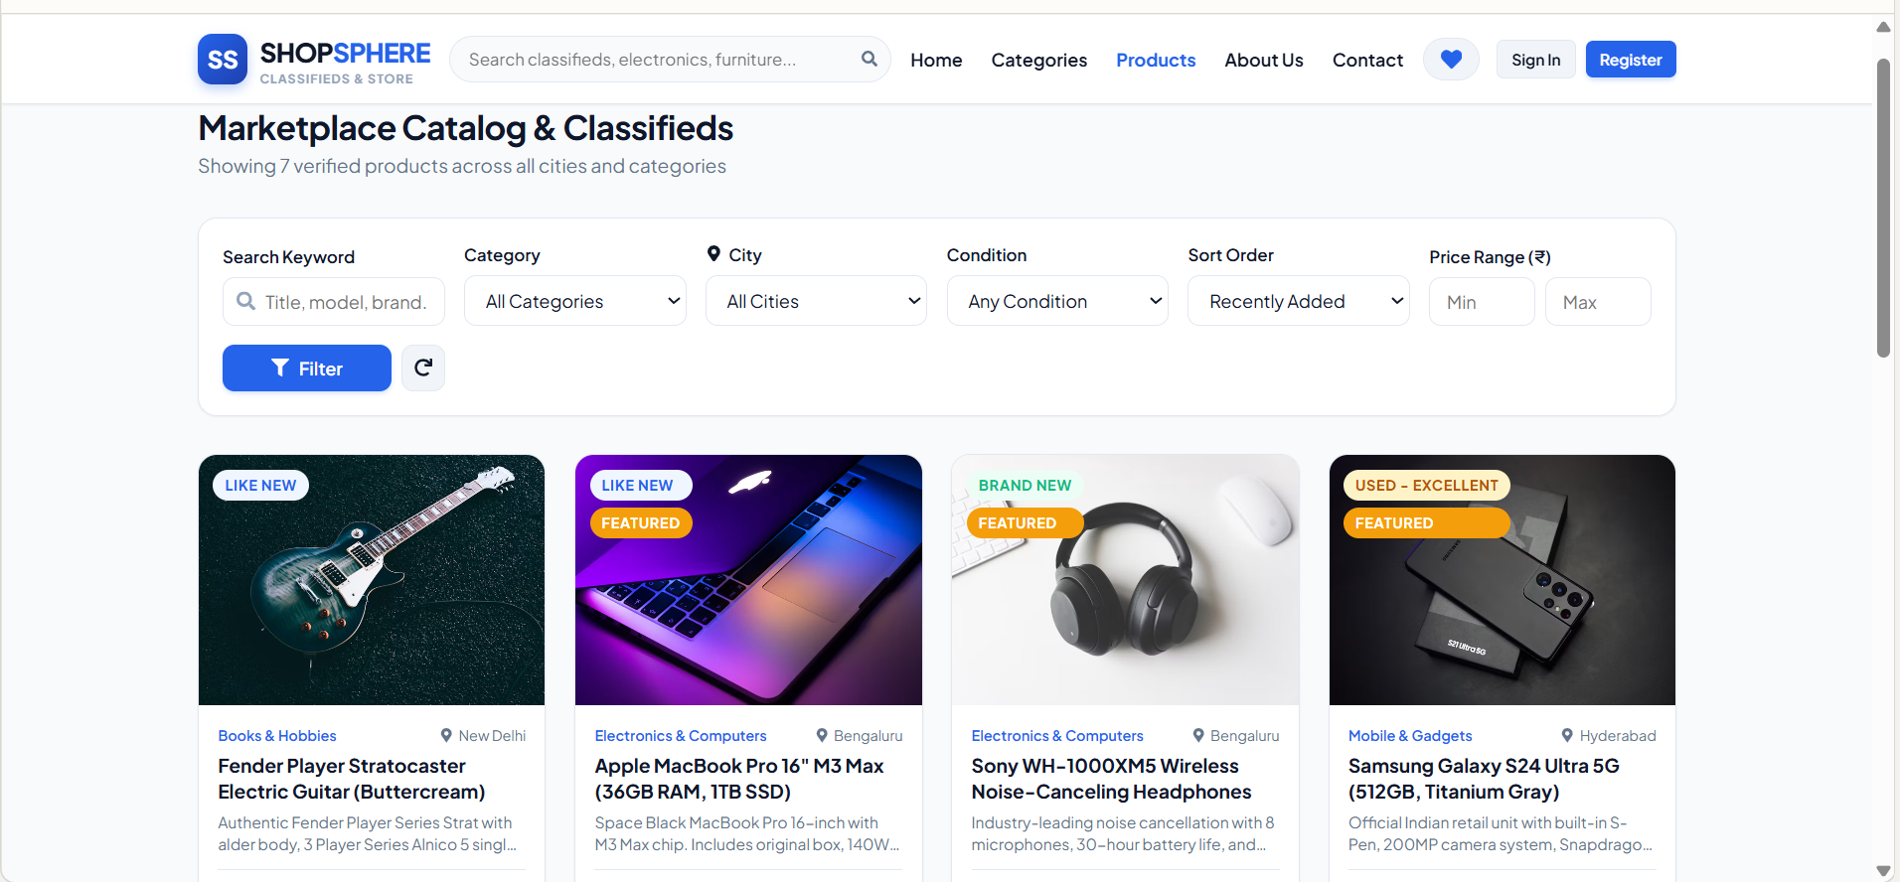
Figure 3: Product Listing and Details
Show product cards and a product details page containing image, name, price, description, seller information, condition, and location.
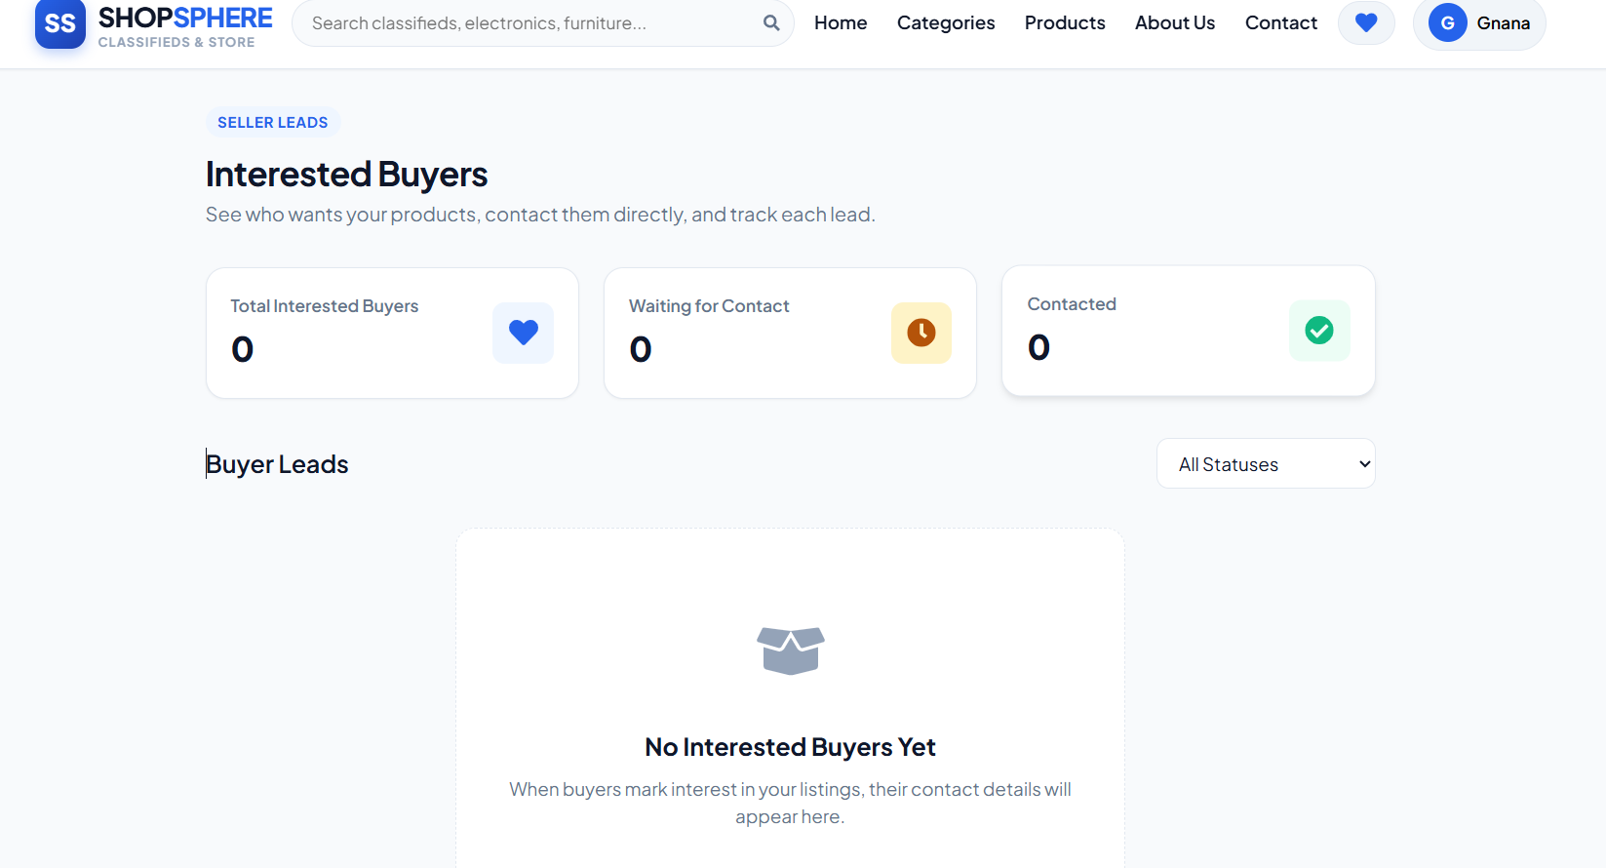
Figure 4: Interested Buyers

6.3 Seller Module Results
This section should contain screenshots of the seller dashboard, add product form, product listing management, edit product page, and seller order management page.
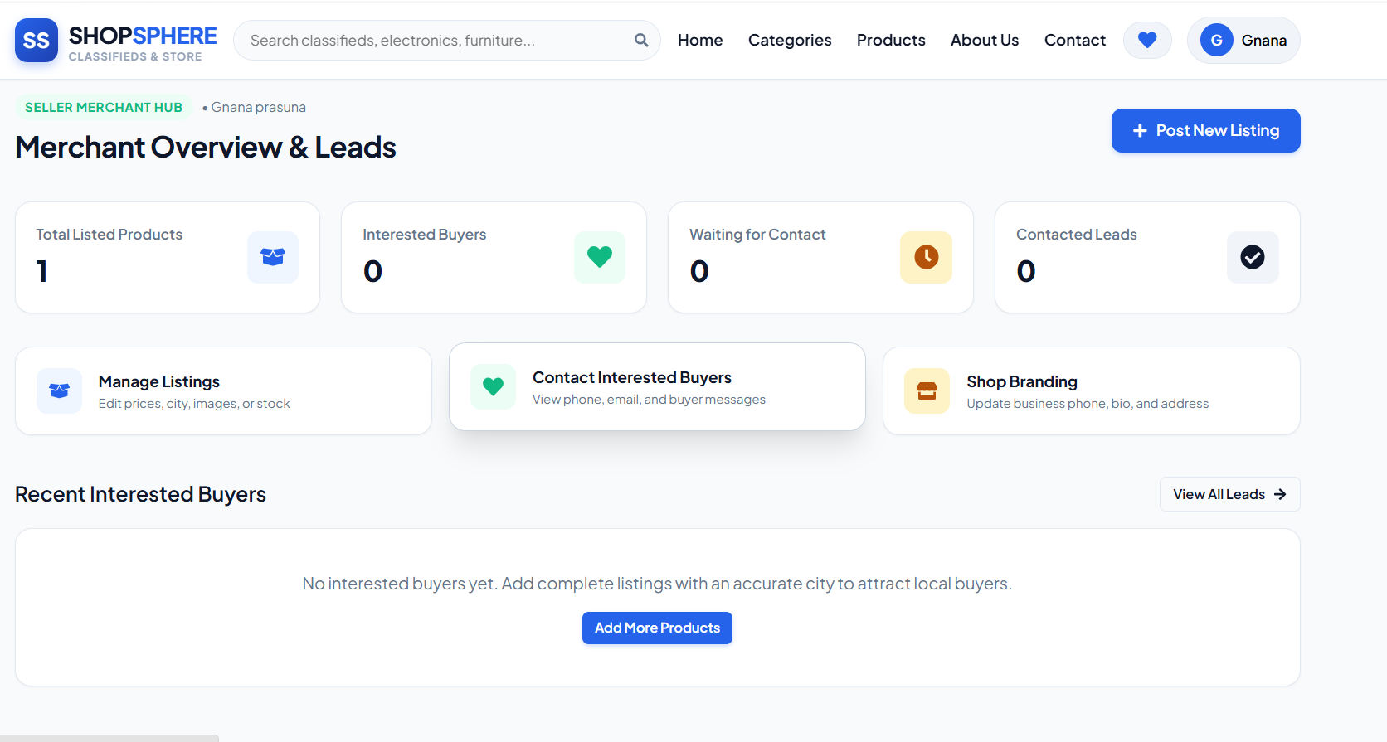
Figure 5: Seller Dashboard and Product Management
Show seller-specific statistics and the seller's own product listings.
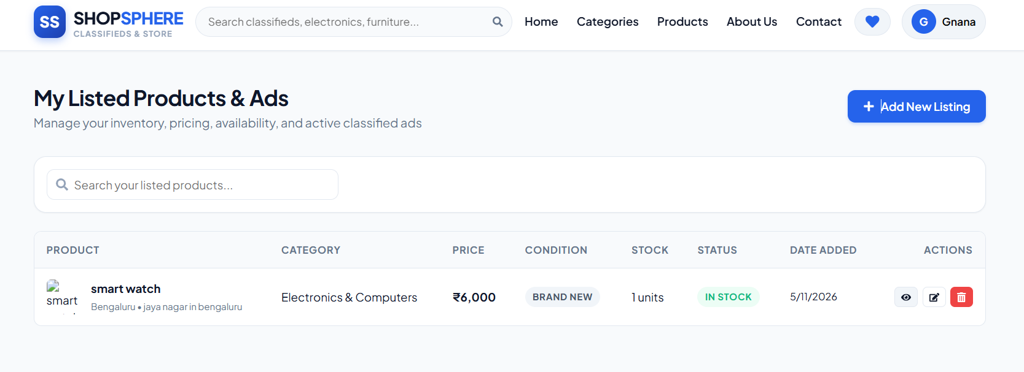
Figure 6: Seller Orders Page
Show orders containing the seller's products and available order status controls.

6.4 Admin Module Results
This section should contain screenshots of the admin dashboard and management pages for users, sellers, categories, products, and orders.
Show total registered users, sellers, products, and orders.
Show account controls, category CRUD, product management, and order monitoring.

6.5 Overall System Result
The SHOP SPHERE online classified advertisement and shopping platform provides a user-friendly environment for customers and sellers to manage their online shopping activities. The system allows users to register, log in, browse products, view product details, add items to their cart, and place orders. Users can also access their order history to view previous purchases and track order status.
The seller module provides a dedicated dashboard through which sellers can manage their products and customer orders. Sellers can add new products, update product details, change prices, upload product images, and delete products. The seller order management page allows sellers to view received orders and update their status, such as pending, confirmed, shipped, and delivered.
The system integrates the frontend, backend, and database to manage user information, product details, cart items, and order records. Overall, SHOP SPHERE is designed to simplify online buying and selling by providing separate functionalities for users and sellers, improving product management, order tracking, and shopping convenience.

CHAPTER 7
CONCLUSION AND FUTURE ENHANCEMENT

7.1 Conclusion
SHOP SPHERE is proposed as a modern MERN stack online classified advertisement and shopping platform inspired by the Java-based ClassifiedShop project. The application is designed to provide a common platform where users can discover products and place orders, sellers can publish and manage their own product listings, and administrators can supervise platform activities.
The proposed architecture uses React.js and Vite for the frontend, Node.js and Express.js for backend REST APIs, and MongoDB with Mongoose for database management. JWT authentication, bcrypt password hashing, role-based authorization, and seller ownership checks are included to protect application data and operations. The system also includes product image upload handling, cart management, order history, category management, and admin statistics.
The project aims to improve product discovery, listing management, and the overall shopping experience through a responsive and organized interface. The final conclusion on successful implementation should be updated after the application has been developed, integrated, and tested.

7.2 Future Enhancements
- Payment Gateway Integration: integrate a secure payment provider for real online transactions.
- Real-Time Notifications: notify users and sellers about order placement and status changes.
- Buyer–Seller Chat: provide secure communication for product enquiries.
- Reviews and Ratings: allow verified buyers to rate products and sellers.
- Wishlist: allow users to save products for later.
- Advanced Search: add price range, location, condition, and sorting filters.
- Cloud Image Storage: use a cloud storage service for scalable image hosting.
- Delivery Tracking: integrate shipment and delivery status tracking.
- Analytics and Reports: provide sales trends, popular categories, and platform activity reports.
- Mobile Application: develop Android and iOS applications.

7.3 Final Summary
SHOP SPHERE defines a full-stack classified shopping solution with separate user, seller, and admin modules. Its modular MERN architecture is intended to support secure authentication, product CRUD operations, cart and order workflows, and centralized administration. Further development, testing, and deployment will convert this proposed design into a complete working application.

